Unequal Air Quality Standards, Unequal Pollution Burdens

Purushottam Gupta & Hrishikesh Chandra Gautam
__________________________________________________________________________
This analysis represents our first-cut analysis. Have critical comments or suggestions? Please email us at guptap@uchicago.edu / hcgautam@uchicago.edu

What national PM_{2.5} standards reveal about regulatory ambition and global life expectancy
National air quality standards are one of the clearest signals governments can send about the level of pollution they consider acceptable. Yet the global regulatory landscape for fine particulate matter (PM₂.₅) remains highly uneven. Across the 252 countries and territories covered by this analysis, only 96 have adopted a national annual PM_{2.5} standard (Figure 1). Those jurisdictions account for approximately 81.9 percent of the global population covered by the analysis, underscoring that the global challenge is not only whether a standard exists, but how protective that standard is and whether countries can actually attain it.
The 2021 World Health Organization (WHO) air quality guidelines provide a useful benchmark. WHO recommends an annual PM_{2.5} concentration of 5 µg/m³ and sets interim targets of 35, 25, 15, and 10 µg/m³ to support stepwise progress toward that guideline (WHO, 2021). When national standards are placed against this ladder, a striking pattern emerges: much of the world technically lives under PM_{2.5} regulation, but a large share of that regulation remains substantially less protective than WHO health-based benchmarks.
Figure 1. Global map of national annual PM_{2.5} standards
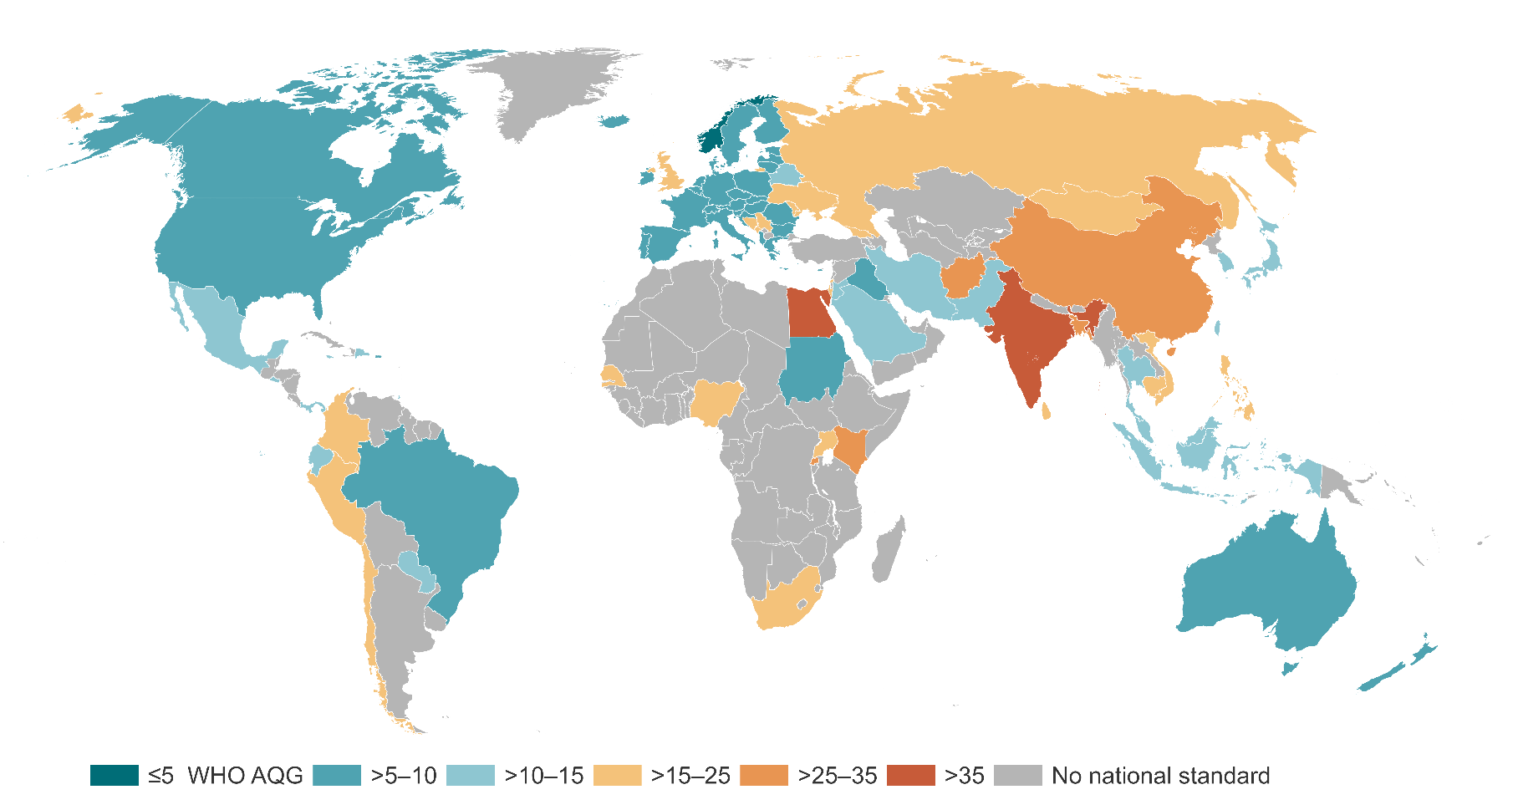
Source:
National annual PM_{2.5} standards vary widely across countries and territories. Many jurisdictions still lack a standard, while many existing standards remain far above WHO guideline levels.

1. Most jurisdictions still lack a national PM_{2.5} standard
Of the 252 countries and territories covered by the analysis, 156 have no official national annual PM_{2.5} standard. The absence of standards is geographically widespread, with the largest number of jurisdictions without standards in Africa. Country counts alone, however, can be misleading: a small island territory and a country with hundreds of millions of people each count as one jurisdiction. Population-weighted measures therefore provide a more meaningful picture of regulatory coverage.
Approximately 81.9 percent of the global population covered by the analysis lives in a country or territory with a national annual PM_{2.5} standard, while about 18.1 percent does not. The global regulatory gap is therefore better described as two related problems: a large number of jurisdictions still lack standards, and many of the standards that do exist remain weak relative to WHO guidance.
Figure 2. Countries Without a National Annual PM_{2.5} Standard, by Continent
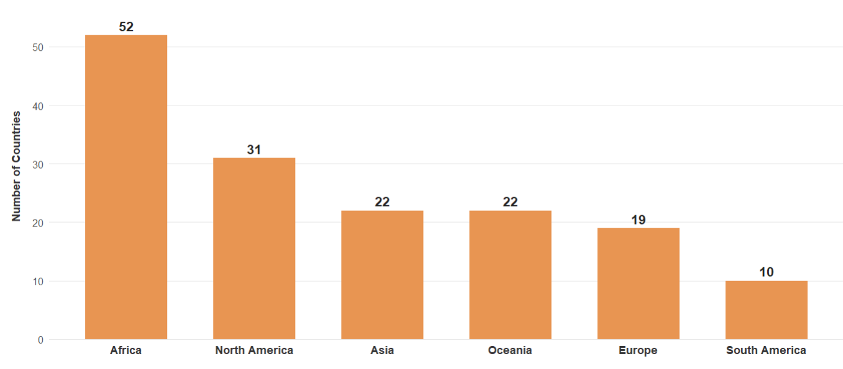
Source:
2. Air quality ambition differs sharply across countries
The WHO framework is explicitly designed as a progression: 35 µg/m³ (Interim Target 1), 25 (IT-2), 15 (IT-3), 10 (IT-4), and ultimately the 5 µg/m³ guideline. This distinction matters because simply classifying countries as “regulated” or “unregulated” hides enormous variation in the level of protection implied by national standards.
Among people living in countries that have an annual PM_{2.5} standard, approximately 78.1 percent live in jurisdictions where the standard is 15 µg/m³ or higher. That is roughly 64 percent of the global population covered by the analysis (Figure 3). A standard of 35 µg/m³, for example, permits an annual concentration seven times the WHO guideline; a standard of 40 µg/m³ permits eight times the guideline.
The global landscape is therefore better understood as a continuum of regulatory ambition: no standard, standards aligned with the least stringent WHO interim targets, progressively stronger standards, and finally standards approaching the WHO guideline.

Figure 3. Population living under different PM_{2.5} standard categories
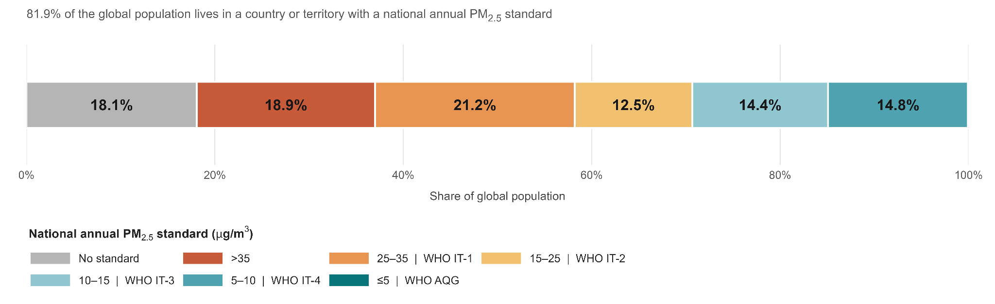
Source:
Although most jurisdictions lack a national annual PM_{2.5} standard, most of the global population lives in countries that do have one. However, much of that population remains covered by standards that are weak relative to WHO interim targets.

3. Weaker regulatory ambition coincides with higher pollution and larger longevity losses
The policy relevance of these differences becomes clearer when national standards are compared with actual pollution exposure. AQLI combines satellite-derived annual PM_{2.5} estimates with population data to characterize the concentrations experienced by people rather than averaging pollution uniformly across land area.
According to AQLI’s 2024 satellite-derived, population-weighted PM_{2.5} estimates, countries with national standards below 15 µg/m³ had an average population-weighted concentration of approximately 12.5 µg/m³. Across countries with standards of 15 µg/m³ or higher, together with countries lacking a national standard, the corresponding concentration was approximately 29.0 µg/m³.
AQLI translates sustained particulate pollution exposure into its effect on life expectancy. Based on the Huai River research underlying the Index, a sustained increase of 10 µg/m³ in PM_{2.5} is associated with approximately 0.98 years of reduced life expectancy (Chen et al., 2013; Ebenstein et al., 2017). Applying this relationship to 2024 exposure shows a similarly large gap across regulatory groups: populations in countries with standards below 15 µg/m³ lose about 0.7 years of life expectancy relative to the WHO guideline, compared with approximately 2.4 years among populations living under standards of 15 µg/m³ or higher or with no national standard.
Figure 4. Life expectancy loss by regulatory category
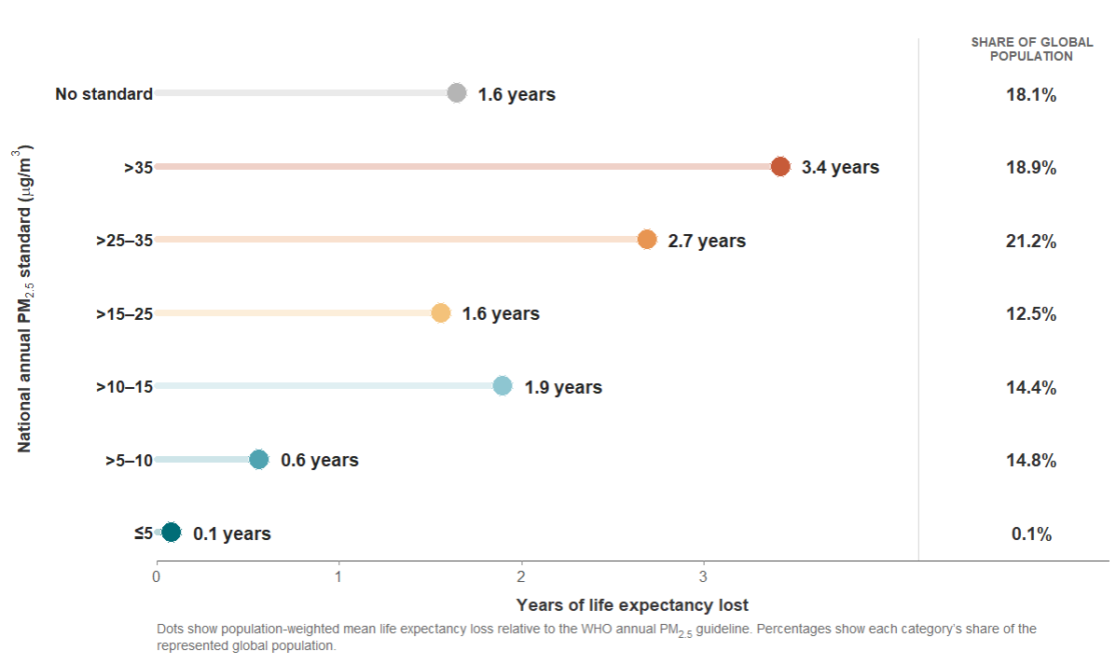
Source:
This difference should not be interpreted as the causal effect of adopting a stricter standard. Regulatory stringency is correlated with income, industrial structure, energy systems, institutional capacity, geography, historical pollution, and many other determinants of air quality. The result is descriptive: countries with weaker or absent standards also tend to be those where pollution exposure and AQLI-estimated longevity losses are substantially higher.
4. The next WHO target offers a practical policy benchmark
For countries with annual PM_{2.5} concentrations several times higher than the WHO guideline, immediately reaching 5 µg/m³ may be difficult. WHO’s interim targets are useful precisely because they provide a sequence of increasingly protective milestones. A practical AQLI counterfactual is therefore to ask how much life expectancy could be gained if countries reduced sustained PM_{2.5} exposure to the next more stringent WHO step.
In this scenario, countries without a national PM₂.₅ standard would move toward 35 µg/m³; countries with standards above 35 would move to 35; those between 25 and 35 would move to 25; those between 15 and 25 would move to 15; those between 10 and 15 would move to 10; and those between 5 and 10 would move to the 5 µg/m³ guideline. Countries already at or below 5 would remain there.
If sustained PM_{2.5} concentrations were reduced to these next-step targets, population-weighted global life expectancy would increase by approximately 0.74 years, equivalent to about 5.9 billion total life-years across the global population represented in the analysis.
Figure 5. Potential life expectancy gain from achieving the next WHO target
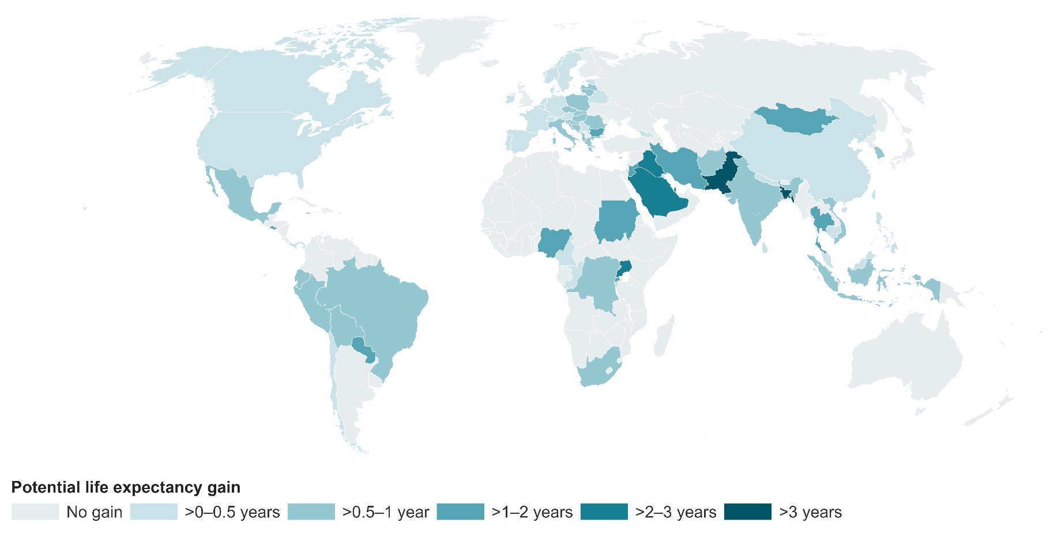
Source:
Crucially, this is a target-attainment scenario, not an estimate of the causal impact of passing a law. A legal standard has no direct health effect if pollution remains unchanged. The life-expectancy gains arise from actually reducing sustained PM_{2.5} exposure.
5. Standards establish ambition; implementation determines outcomes
National standards remain important because they establish measurable objectives against which air quality can be monitored, policies designed, and progress evaluated. But standards must be paired with the capacity to attain them. Depending on local sources, this can require controls on power generation and industry, cleaner household energy, transport and fuel standards, agricultural interventions, dust controls, and sufficiently robust monitoring to determine whether pollution is actually falling.
The global air quality challenge is therefore no longer captured by the question, “Does a country have a PM_{2.5} standard?” The more consequential questions are: How stringent is the standard? How far is current exposure from that level? And are policies strong enough to close the gap?
The WHO interim targets provide a practical pathway. For highly polluted countries, progress need not occur in a single leap from today’s concentrations to 5 µg/m³. Moving successively toward 35, 25, 15, 10, and ultimately 5 µg/m³ creates measurable milestones. Because sustained PM_{2.5} exposure has a quantifiable effect on longevity, each durable reduction can translate into longer lives.
The next frontier in global air quality policy is thus not merely broader adoption of standards, but progressively stronger standards backed by policies capable of delivering cleaner air.
Methodological note
Developing a national standard takes effort in terms of current technological/ abatement and monitoring resources in the country as well as policy and legal/constitutional framework of the country. The dynamic nature of these conditions makes it hard to keep tabs on national standards as countries adopt and update standards over time. Team at AQLI have developed a tracker for National Annual PM_{2.5} standards. It’s a dynamic tracker and we encourage readers to look at it and help us in keeping the values updated. You can find the details here. This analysis combines national annual PM₂.₅ standards with AQLI’s 2024 satellite-derived, population-weighted annual PM_{2.5} estimates. It covers 252 countries and territories, of which 96 have a recorded national annual PM₂.₅ standard. Life-expectancy impacts are interpreted using the relationship in which a sustained 10 µg/m³ increase in PM_{2.5} corresponds to approximately 0.98 years of reduced life expectancy. Comparisons across regulatory categories are descriptive and should not be interpreted as causal estimates of the effect of regulation.
References
Chen, Y., Ebenstein, A., Greenstone, M., & Li, H. (2013). Evidence on the Impact of Sustained Exposure to Air Pollution on Life Expectancy from China’s Huai River Policy. Proceedings of the National Academy of Sciences, 110(32), 12936–12941.
Ebenstein, A., Fan, M., Greenstone, M., He, G., & Zhou, M. (2017). New Evidence on the Impact of Sustained Exposure to Air Pollution on Life Expectancy from China’s Huai River Policy. Proceedings of the National Academy of Sciences.
World Health Organization. (2021). WHO Global Air Quality Guidelines: Particulate Matter (PM_{2.5} and PM₁₀), Ozone, Nitrogen Dioxide, Sulfur Dioxide and Carbon Monoxide.
Air Quality Life Index (AQLI), Energy Policy Institute at the University of Chicago. AQLI methodology and 2024 satellite-derived, population-weighted PM_{2.5} exposure data.

AQLI database of national ambient annual PM_{2.5} standards. National standards database

